**Project 1**

**Title:**

Beetles!

**Course:**

CSC-5

**Section:**

46023

**Due Date:**

July 21, 2014

**Author:**

Allison Lomheim

**Introduction**

Title: Beetle!

Beetle is played by competing against someone to try and be the first to draw a complete

beetle. The rules are that you have one die and you depending on the number you roll, you draw the body part. For example, if you were to roll a 6, you would get to draw the body. You must roll a six first, otherwise you will not be able to draw anything else. Then you must roll a 5 to get the head. After a 5 and 6 it does not matter what you roll, it becomes how much you roll. For instance, you must roll a 1 twice in order to get two eyes. You must roll a 2 twice for both antenna. You must roll a 4 twice for both wings. And finally you must roll a 3 six times to get all six legs. Once again, the person with the least amount of tosses is the winner.

**Summary**

Projectsize: 900+ lines

The number of variables: Roughly about 50.

The number of methods: About 10.

This game is very long code wise due to the ability to have 2 or 3 players. I was going to do more but I felt it would have been unnecessarily long and would have taken much, much longer. It would have reached around 2,000-5,000 lines just for the addition of characters. Every method used was completely necessary in the completion of this project. It displays the amount of rolls done before the correct number was rolled. I went up to 100 rolls because anymore would have been illogical, people would have gotten tired by then, and I wanted it to be as close to a random game as possible.

This program took around 5 days to complete.

It was difficult and confusing due to the amount of variables, but for random numbers they were necessary.

There is probably a better way of coding this by using arrays, but I am not too familiar with them yet. I used all concepts that we learned in class.

**Description**

The point of this function is to use a random number generator in order to get all the bug parts necessary to draw a beetle.

**Flowchart**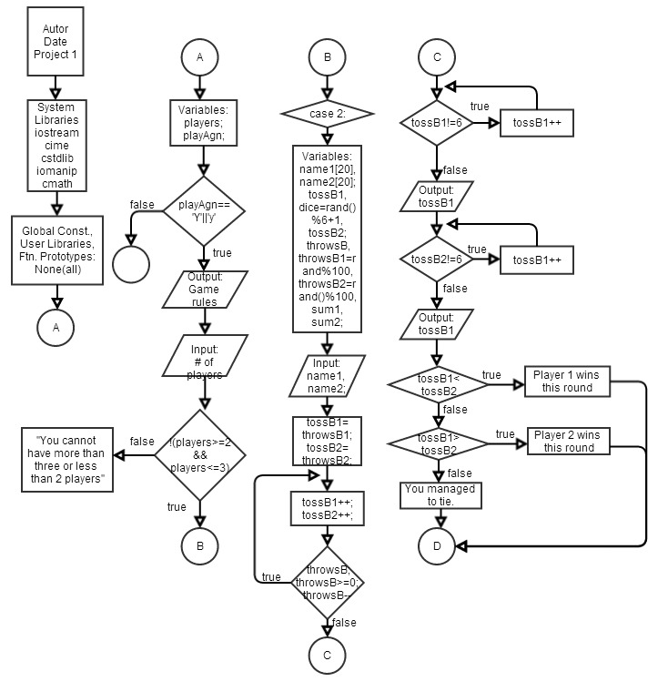 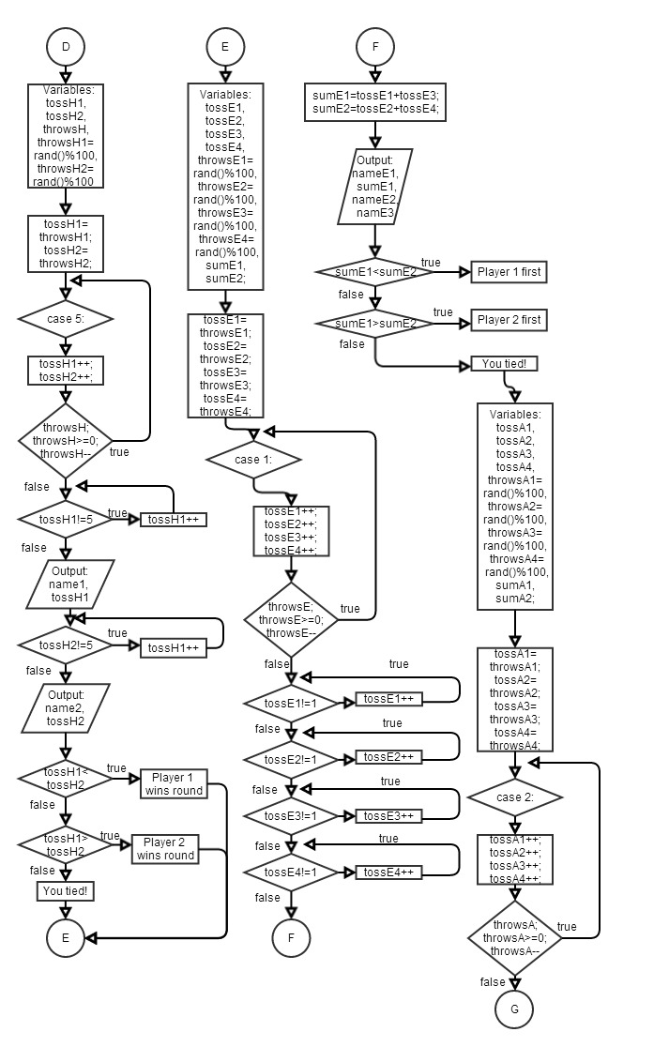

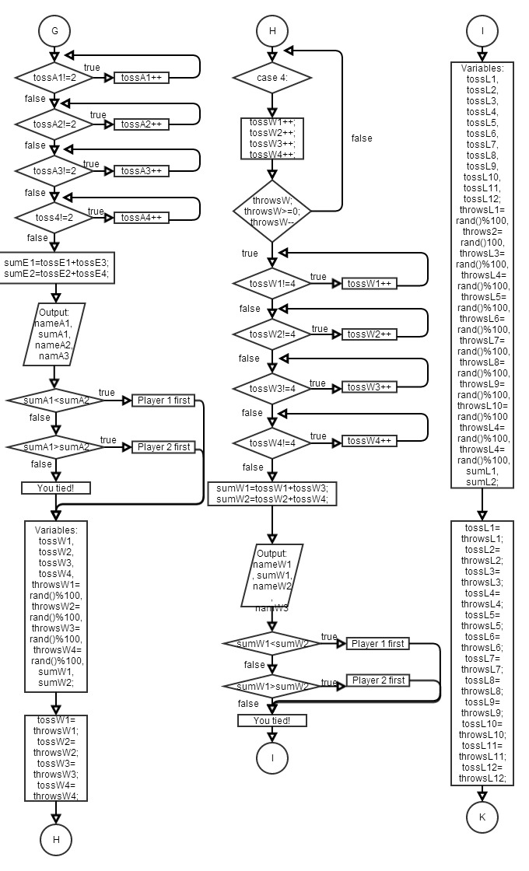

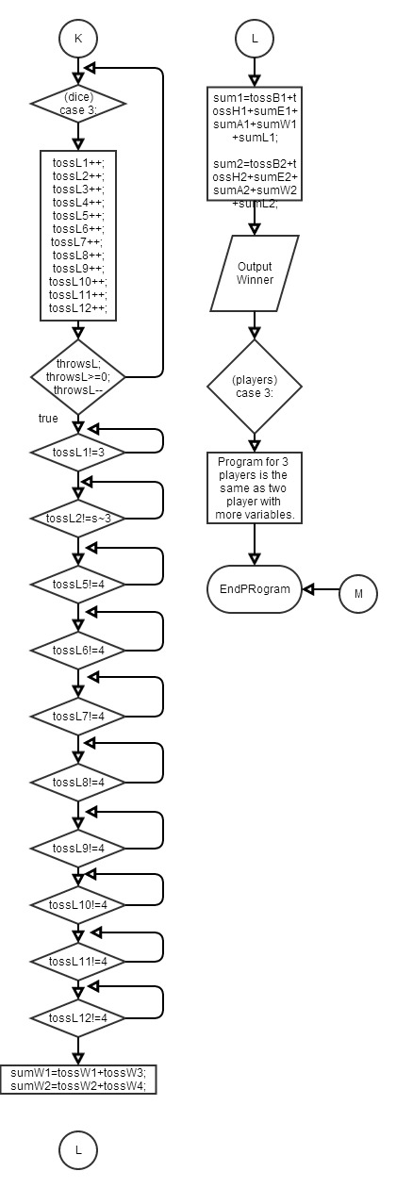

**Pseudocode**

Initialize

Display rules

Case 2 players

Insert name 1 (player 1)

Insert name 2 (player 2)

(For the body)

If you don’t roll a six, try again player 1

If you don’t roll a six, try again player 2

Player 1 took this many rolls

Player 2 took this many rolls

If player 1 rolled less, round win

Else if player 2 rolled less, round win

Else tie

(For the head)

If you don’t roll a five, try again player 1

If you don’t roll a five, try again player 2

Player 1 took this many rolls

Player 2 took this many rolls

If player 1 rolled less, round win

Else if player 2 rolled less, round win

Else tie

(For the eyes)

If you don’t roll a 1 twice, try again player 1

If you don’t roll a 1 twice, try again player 2

Sum the rolls together for player 1

Sum the rolls together for player 2

Player 1 took this many rolls

Player 2 took this many rolls

If player 1 rolled less, round win

Else if player 2 rolled less, round win

Else tie

(For the antenna)

If you don’t roll a 2 twice, try again player 1

If you don’t roll a 2 twice, try again player 2

Sum the rolls together for player 1

Sum the rolls together for player 2

Player 1 took this many rolls

Player 2 took this many rolls

If player 1 rolled less, round win

Else if player 2 rolled less, round win

Else tie

(For the wings)

If you don’t roll a 4 twice, try again player 1

If you don’t roll a 4 twice, try again player 2

Sum the rolls together for player 1

Sum the rolls together for player 2

Player 1 took this many rolls

Player 2 took this many rolls

If player 1 rolled less, round win

Else if player 2 rolled less, round win

Else tie

(For the antenna)

If you don’t roll a 3 six times, try again player 1

If you don’t roll a 3 six times, try again player 2

Sum the rolls together for player 1

Sum the rolls together for player 2

Player 1 took this many rolls

Player 2 took this many rolls

If player 1 rolled less, round win

Else if player 2 rolled less, round win

Else tie

Calculate sum of all rolls for player 1

Calculate sum of all rolls for player 2

If player 1 sum is less than player 2’s, player 1 wins game

Else if player 2 sum is less than player 1’s, player 2 wins game

Else they both miraculously tie

Break

Case 3 players

Insert name 1 (player 1)

Insert name 2 (player 2)

Insert name 3 (player 3)

(For the body)

If you don’t roll a six, try again player 1

If you don’t roll a six, try again player 2

If you don’t roll a six, try again player 3

Player 1 took this many rolls

Player 2 took this many rolls

Player 3 took this many rolls

If player 1 rolled less, round win

Else if player 2 rolled less, round win

Else if player 3 rolled less, round win

Else tie

(For the head)

If you don’t roll a five, try again player 1

If you don’t roll a five, try again player 2

If you don’t roll a five, try again player 3

Player 1 took this many rolls

Player 2 took this many rolls

Player 3 took this many rolls

If player 1 rolled less, round win

Else if player 2 rolled less, round win

Else if player 3 rolled less, round win

Else tie

(For the eyes)

If you don’t roll a 1 twice, try again player 1

If you don’t roll a 1 twice, try again player 2

If you don’t roll a 1 twice, try again player 3

Sum the rolls together for player 1

Sum the rolls together for player 2

Sum the rolls together for player 3

Player 1 took this many rolls

Player 2 took this many rolls

Player 3 took this many rolls

If player 1 rolled less, round win

Else if player 2 rolled less, round win

Else if player 3 rolled less, round win

Else tie

(For the antenna)

If you don’t roll a 2 twice, try again player 1

If you don’t roll a 2 twice, try again player 2

If you don’t roll a 2 twice, try again player 3

Sum the rolls together for player 1

Sum the rolls together for player 2

Sum the rolls together for player 3

Player 1 took this many rolls

Player 2 took this many rolls

Player 3 took this many rolls

If player 1 rolled less, round win

Else if player 2 rolled less, round win

Else if player 3 rolled less, round win

Else tie

(For the wings)

If you don’t roll a 4 twice, try again player 1

If you don’t roll a 4 twice, try again player 2

If you don’t roll a 4 twice, try again player 3

Sum the rolls together for player 1

Sum the rolls together for player 2

Sum the rolls together for player 3

Player 1 took this many rolls

Player 2 took this many rolls

Player 3 took this many rolls

If player 1 rolled less, round win

Else if player 2 rolled less, round win

Else if player 3 rolled less, round win

Else tie

(For the antenna)

If you don’t roll a 3 six times, try again player 1

If you don’t roll a 3 six times, try again player 2

If you don’t roll a 3 six times, try again player 3

Sum the rolls together for player 1

Sum the rolls together for player 2

Sum the rolls together for player 3

Player 1 took this many rolls

Player 2 took this many rolls

Player 3 took this many rolls

If player 1 rolled less, round win

Else if player 2 rolled less, round win

Else if player 3 rolled less, round win

Else tie

Calculate sum of all rolls for player 1

Calculate sum of all rolls for player 2

Calculate sum of all rolls for player 3

If player 1 sum is less than player 2’s, player 1 wins game

Else if player 2 sum is less than player 1’s and 3’s, player 2 wins game

Else if player 3 sum is less than player 1’s and 2’s, player 3 wins game

Else they all miraculously tie

Break

Play again?

While yes, play again

Otherwise end program